CAMERA User’s Guide

1 Quick Start

CAMERA is a collection of concise, intuitive and visually inspiring workbenches for cache mapping schemes and virtual memory. The CAMERA workbenches are standalone applications that can be used independently of each other and any external tools. The package is comprised of four independent Java Swing applications illustrating the following concepts:
- Cache Mapping Schemes
- Direct Mapped Cache
- Fully Associative Cache
- Set Associative Cache
- Virtual Memory and Paging

They are most easily launched from the main menu application. To do this, all the class files must reside in the same directory.

1.1 Installation
After downloading Camera.zip, move the file to its desired location. Then unzip the files. The files may be compiled by typing the following command:
javac *.java
Issuing the following command will bring up the menu screen:
java Camera

The CAMERA workbenches are written in Java Swing and can be run on any platform on which the Java Runtime Environment (JRE), version 1.3.1 or greater, resides.

1.2 Model System Specifications
The menu screen allows the user to launch any of the workbenches by clicking the appropriate button.

When the user launches an application, the progress field supplies the specifications of the system that has been modeled in the application, such as cache and memory size, virtual memory space, page and block sizes, and binary address size. In the cache mapping applications, cache size is 16 blocks; memory size is 32 blocks with 8 words per block hence the binary address is 8 bits in length. In the virtual memory application, the virtual memory space for each process has been set at 2⁸ words, which translates to 8 pages of 32 words each. The physical memory contains 2⁷ words hence it is divided into 4 page frames of 32 words each. The TLB can hold up to 4 entries. Where applicable, the replacement algorithm used for choosing the “victim” block is the LRU algorithm.

1.3 Beginning a Simulation
The user is required to generate an initial address reference string, which will be used to begin a simulation cycle. There are two options available to the user:
- Choose to let the application generate a string of 10 hexadecimal addresses in the range 00 – FF by clicking on the button, shown in Figure 17, on the left hand side of the screen:

Figure 1: Auto Generate String

The “Auto Generate Add. Ref. Str.” button may be clicked repeatedly before clicking “Next” if the user wishes to generate more than 10 addresses at once.

- Enter individual address references by clicking on the button, illustrated in Figure 18, on the left hand side of the screen:

Figure 2: Self Generate String

The user can then proceed to enter up to 10 valid hexadecimal addresses ranging from 00 – FF. (If more addresses are desired, additional addresses can be added later.)

In the set associative cache mapping simulator, there is an additional option for specifying the number of "ways" (cache blocks per set) in the cache. The user is prompted to pick one of the available choices and the cache is redesigned dynamically. This option can be exercised by clicking on the button, illustrated in Figure 19, located under the cache on the lower left area of the screen:


Figure 3: Number of Ways

These generation buttons and the button for selecting the number of ways are disabled during a simulation cycle so that the flow of the simulation cannot be disturbed. They are enabled again after the address reference string has been exhausted. Clicking on the “Restart” button can allow the user to stop the current simulation and bring the simulator back to starting position if so desired. The “Restart” button may be used at any time to start afresh, that is, clear the contents of the cache and the address reference string, and reinitialize the count of cache hits and misses so the user can start a new simulation with a new address reference string.

At the end of a simulation cycle, when the address string has been exhausted, the generation buttons are re-enabled to permit the user to generate another set of strings. In this case, the cache is not cleared and the statistics on cache hits and misses are not reinitialized. Since the application restricts the number of addresses generated each time to a maximum of 10, this feature of the address generation buttons allows a user to observe simulation cycles following one after another and thus model a real life example of a set of addresses generated through the execution of a program. The addresses can be added on at the end of each simulation cycle while retaining the state of the memory hierarchy.

1.4 Stepping Through a Simulation
Once the address reference string has been created, the user can step through a simulation cycle while observing the process followed by the CPU to obtain data residing at the address specified by the address reference. The navigation buttons shown in Figure 20 are located at the bottom of the application screen:

Figure 4: Navigation Buttons

The “Next” and “Back” buttons may be used, as their names suggest, for stepping forward to the next stage or stepping backward to the previous stage in the simulation.

At each step, the architectural element being accessed by the CPU is highlighted, demonstrating the process. Additionally, the progress field located at the bottom of the screen explains the steps textually and guides the user to the next step:


Figure 5: Progress Field

2 The Details

2.1 Introduction

CAMERA is a collection of concise, intuitive and visually inspiring workbenches for cache mapping schemes and virtual memory. The best way to learn any new concept is hands-on experience, and CAMERA’s primary goal is to provide students with the means to step along while it demonstrates various concepts of cache mapping and virtual memory. Workbenches, by their very nature, lend themselves to exploration and with CAMERA, students can modify some basic features of the components and follow their changes through the cycle of the application. Although a well-written book with diagrams and illustrations can be very educational, a simulation that models the actual process and also allows user input and manipulation can provide an entirely new perspective to learning. CAMERA was developed to satisfy this need for a dynamic new instructional tool. It gives students graphical representations of the memory system and furnishes them with appropriately flexible interfaces to observe and experiment with the system.

Another objective for developing CAMERA was to use it in conjunction with the memory architecture simulator, MarieSim (also available on the textbook web page). Toward the goal of helping students understand how computers really work, we created a memory architecture called MARIE and made it as simple as possible, hence the name Machine Architecture that is Really Intuitive and Easy. Real architectures, although interesting, often have far too many peculiarities to make them usable in an introductory class. To alleviate these problems, we designed MARIE specifically for pedagogical use. MARIE allows students to learn the essential concepts of computer organization and architecture, including assembly language, without getting caught up in the unnecessary and confusing details that exist in real architectures. Despite its simplicity, it simulates a functional system. The MARIE machine simulator, MarieSim, has a user-friendly GUI that allows students to: (1) create and edit source code; (2) assemble source code into machine object code; (3) run machine code; and, (4) debug programs. It is an environment within which users can write their own programs and watch how they would be run in a real "von Neumann architecture" computer system. This way, they would get to see their programs in action, and get a taste of how to program in an assembler language, without the need to learn any particular assembly language. Together, MarieSim and CAMERA make up a very nice learning tool set for memory architecture concepts.

2.2 Cache Mapping

The three cache mapping schemes depicted in CAMERA are detailed below.

Direct Mapped Cache
In this mapping scheme, each block of memory is mapped to exactly one cache block in a modular fashion. This mapping is determined by the memory address bits that are, in turn, dependent on the physical characteristics of main memory and cache. The memory address is partitioned into three fields: tag, block, and word (or offset). The least significant bits form the word field, which identifies a word in a specific block. The middle bits form the block field, which specifies the cache block to which this memory address maps. The remaining bits form the tag field, which uniquely identifies a memory block in cache. Since there are more blocks in memory than in cache, it is obvious that there is contention for the cache blocks. The tag field is stored with each memory block when it is placed in cache so the block can be uniquely identified. When cache is searched for a specific memory block, the CPU knows exactly where to find the block just by looking at the main memory address bits.

Fully Associative Cache
Instead of specifying a unique location for each main memory block, we can look at the opposite extreme: allowing a block of memory to be placed anywhere in cache. To implement this mapping scheme, we require associative memory so it can be searched in parallel. The memory address is partitioned into two fields: tag and word. The least significant bits form the word field, which identifies a word in a specific block. The remaining bits form the tag field, which uniquely identifies a memory block in cache and is stored with the main memory block in cache. When cache is searched for a specific memory block, the tag field of the main memory block is compared to all the valid tags in cache and, if a match is found, the block is found. If there is no match, the memory block needs to be brought into the cache. As mentioned before, since the number of blocks in memory exceeds the number of blocks in cache, there will be contention for the cache blocks. While there are empty blocks in cache, the memory blocks are placed in the nearest available free cache block. Once cache is full, a replacement algorithm is used to evict an existing memory block from cache and place the new memory block in its place. In CAMERA, the replacement algorithm used is the least recently used (LRU) algorithm.

Set Associative Cache
The third mapping scheme is N-way set associative cache mapping. It is similar to direct mapped cache because we use the memory address to map to a cache location. The difference is that an address maps to a set of cache blocks instead of a single cache block. The memory address is partitioned into three fields: tag, set, and word. The tag and word fields behave the same as before. The set field indicates into which cache set the memory block maps. When cache is searched for a specific memory block, the CPU knows to look in a specific cache set with the help of the main memory address bits. The tag bits then identify the memory block. A replacement algorithm is needed to determine the “victim” block that will be removed from cache to make available free space for a new memory block. In CAMERA, the replacement algorithm used is the LRU algorithm.

2.3 Virtual Memory and Paging

Camera also provides a workbench to reinforce the concepts in virtual memory and paging. Physical memory, virtual memory, the process page table, and the TLB are all available for inspection as students progress though a sequence of addresses. The number of TLB hits and misses, as well as the number of page hits and misses are also recorded. If a page fault occurs and this involves replacing another page in main memory, CAMERA uses the popular LRU replacement algorithm.

2.4 CAMERA Features

CAMERA has many distinctive features:
- Progression through each simulation is illustrated with visual effects and reinforced by the current updates offered by the progress status field.
- Along with the detailed explanation the progress field presents, it also provides guidance to the user on how to proceed to the next step.
- The main memory address retrieved from the address reference string is converted to its binary equivalent at each step to clearly show the user the mapping between the memory address and its corresponding cache location.
- The navigation buttons provide easy maneuverability back and forth so the user doesn’t overlook any important information during a simulation cycle.
- The user is offered several choices in the generation of the address reference string.
- Each workbench represents a snapshot of the memory architecture so the user can perceive it in its entirety in one glance. There are no scrolling controls and no multiple windows that clutter the interface.
- CAMERA, with its workbenches for cache mapping as well as virtual memory, is a comprehensive package of applications for memory management concepts.
- The workbenches are great teaching aids and can assist instructors in explaining memory management concepts and in providing students with interesting tools to further their knowledge of the same.

2.4 CAMERA Functionality
The following screenshots outline the sequence of simulations in CAMERA.

Since the cache mapping simulators have a very similar look and feel, only one of them will be addressed in detail. To assist in clearly describing the cache mapping applications, a walkthrough of Direct Mapped Cache is shown in Figures 6 through 11:

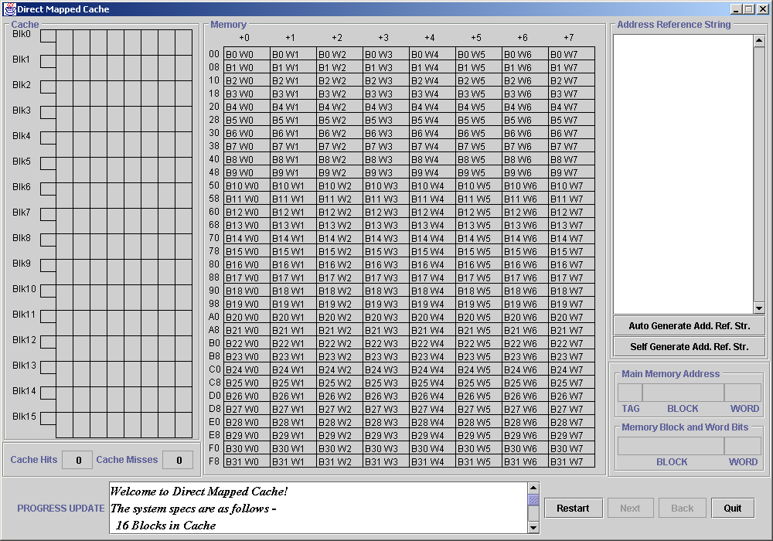
Figure 6: Direct Mapped Cache - Introduction

On the start of the simulation, the cache is clear and the user is prompted to generate an address reference string. There are two options for creation of the string:
    - The user can request that application generate an address reference string of a predefined length. This string would be a segment of an actual address string created during execution of a simple program. (This information can be retrieved from MarieSim)
    - The user can enter single valid addresses one at a time up to a predefined maximum. The main goal of this feature is to allow a user to run a sample program in MarieSim, capture the address reference string from it, and then execute CAMERA’s workbenches to view the flow of data between memory and cache and understand mapping concepts.

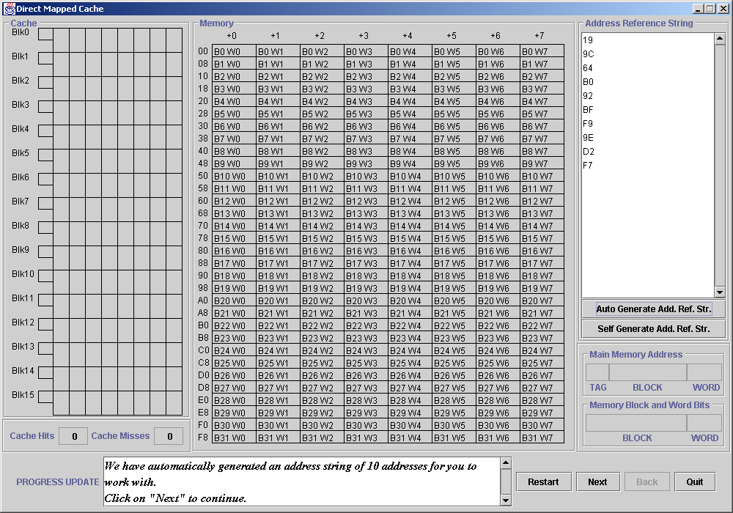
Figure 7: Direct Mapped Cache – Address Reference String

Once the address reference string is created, the simulation can begin. As the user steps forward using the “Next” button, the application retrieves an address from the string, converts it into its binary equivalent and displays the bits, which are partitioned into the tag, block, set and word fields as appropriate to that particular cache mapping scheme.
In the case of Direct Mapped Cache, the main memory address bits are divided into tag, block and word.

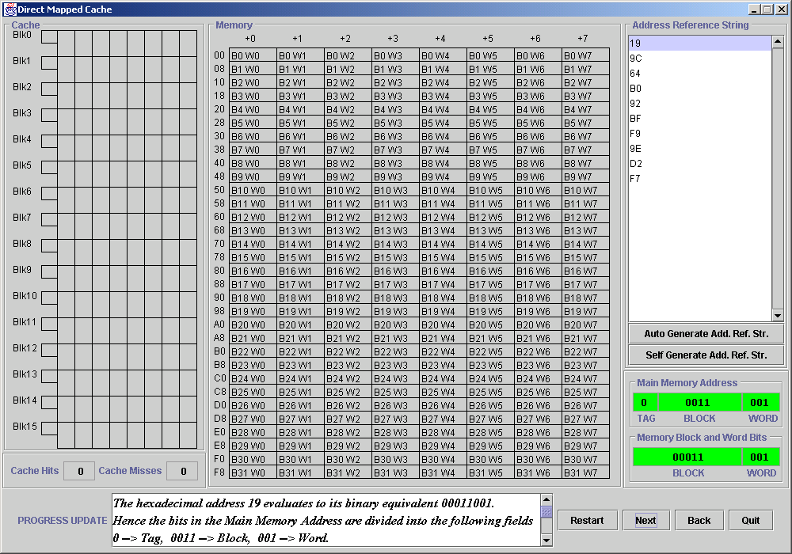
Figure 8: Direct Mapped Cache – Address Bits

There are two sets of bits highlighted in green. The bits on top are the actual generated main memory address bits that indicate the cache location to which the memory block maps. The bits below are not part of the architecture, but simply serve an informational purpose, indicating the main memory block and word in question.

Now that the cache location is determined, the CPU looks in the appropriate cache location for the memory block.

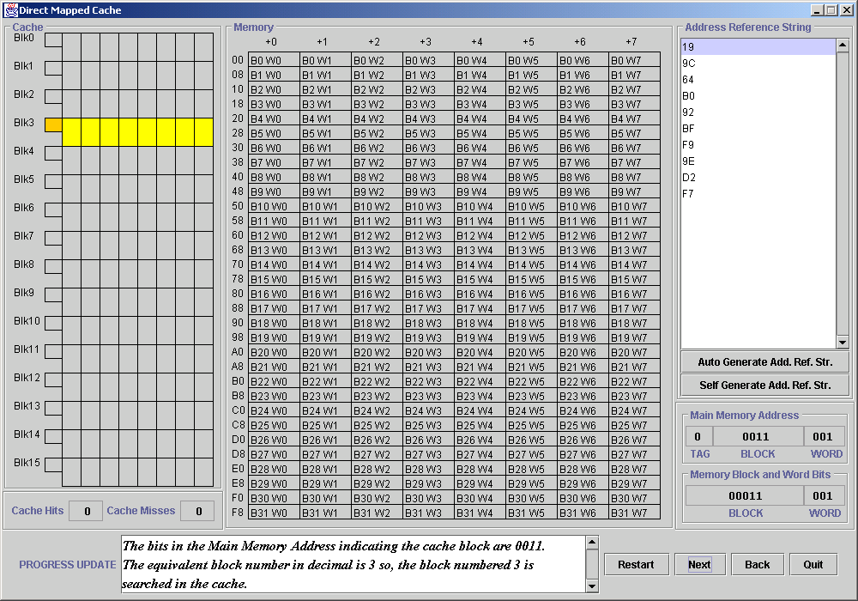
Figure 9: Direct Mapped Cache – Cache Block (empty)

The cache block accessed is highlighted in yellow, and the tag in orange. In this example, there is a cache miss because the required cache block is empty. The count of cache misses is incremented.

Now the memory block needs to be brought into cache. Therefore the CPU goes to memory to access the memory block.

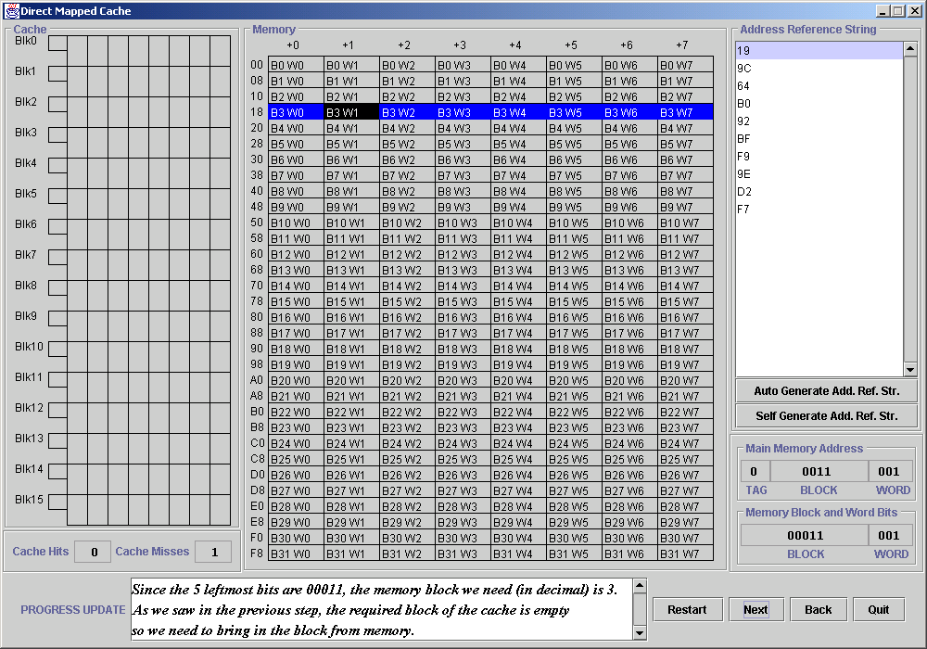
Figure 10: Direct Mapped Cache – Memory Block

The memory block is highlighted in blue, and the required word is highlighted in black.
This block of memory is now transferred into cache.
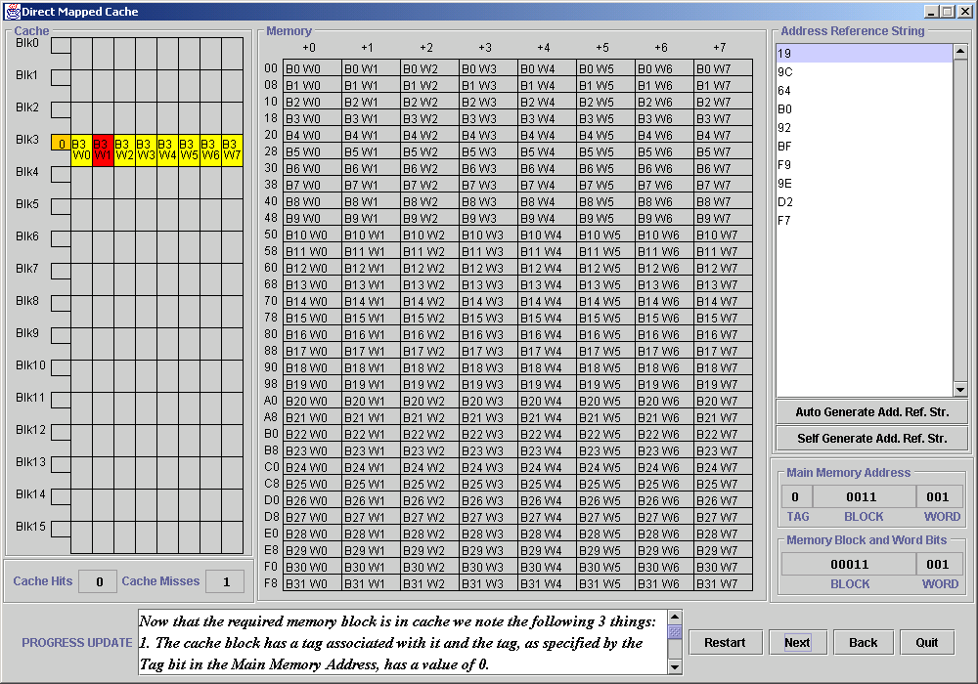
Figure 11: Direct Mapped Cache – Cache Block (full)

The cache now contains the memory block and the CPU can now access the main memory block from here. The required block is highlighted in yellow while the word is highlighted in red. The tag field is also updated and highlighted in orange.

The simulators for fully associative cache and set associative cache have much of the same functionality as direct mapped cache in the way that they illustrate the process starting from the generation of the memory address to the mapping of memory to cache and the retrieval of the memory block. The only differences in the interfaces lie in the partitioning of the bits in main memory address and the cache design.

Here is a screenshot of one of the simulation phases in Fully Associative Cache:

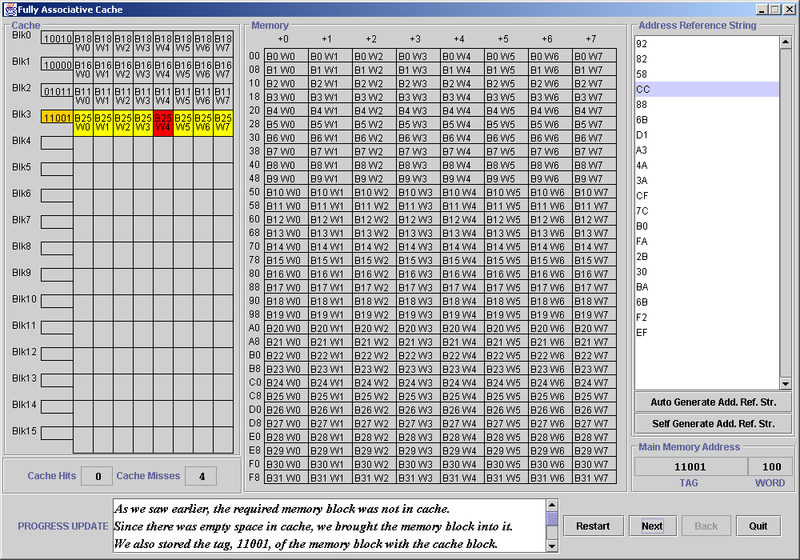
Figure 12: Fully Associative Cache

Here is a screenshot of the interface for 2-way Set Associative Cache:

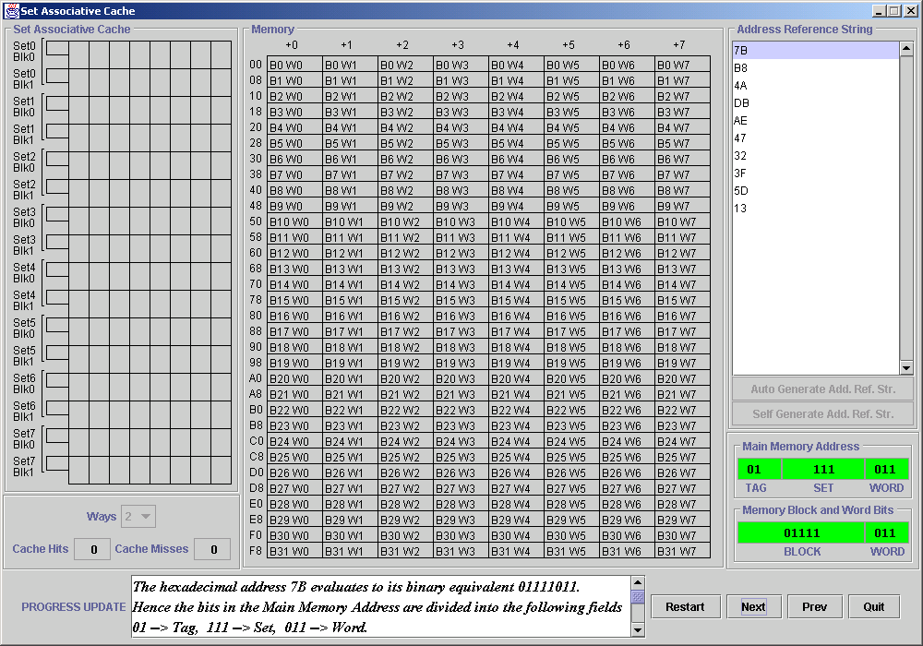
Figure 13: 2-way Set Associative Cache

Here is a screenshot of the interface for 4-way Set Associative Cache:

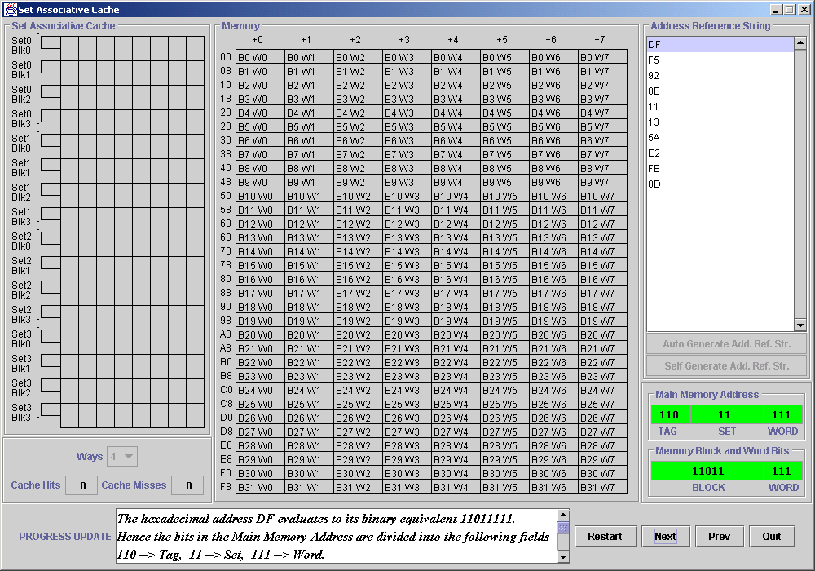
Figure 14: 4-way Set Associative Cache

To assist in clearly describing the Virtual Memory simulator, Figures 15 through 21 outline the sequence of a simulation:

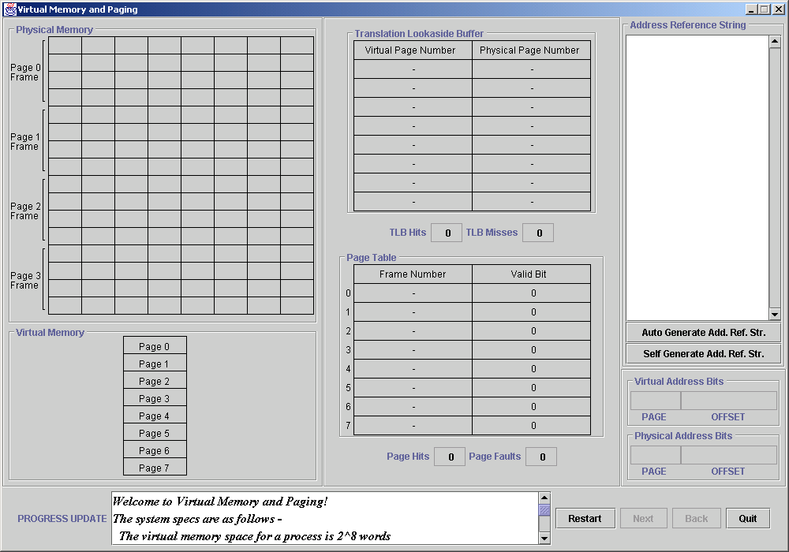
Figure 15: Virtual Memory - Introduction

On the start of the simulation, the physical memory is empty and the user is prompted to generate an address reference string. The two options available are the same as in the cache mapping tutorials.
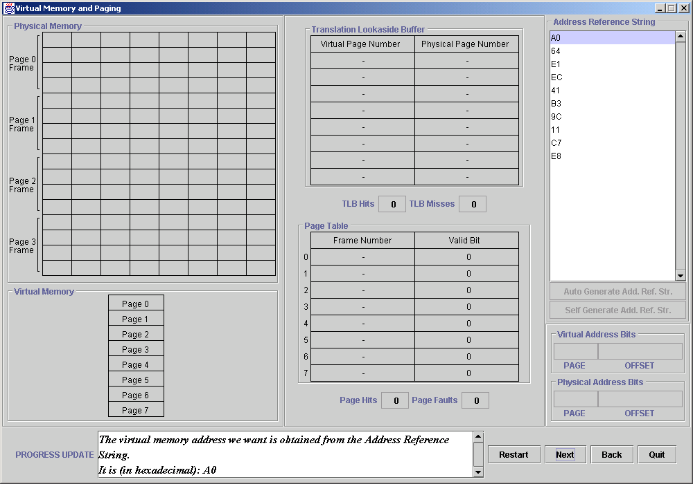
Figure 16: Virtual Memory – Address Reference String

Once the address reference string is created, the simulation can begin. As the user steps forward using the “Next” button, the application retrieves a virtual address from the string, converts it into its binary equivalent and displays the bits, which are partitioned into the page and offset fields.
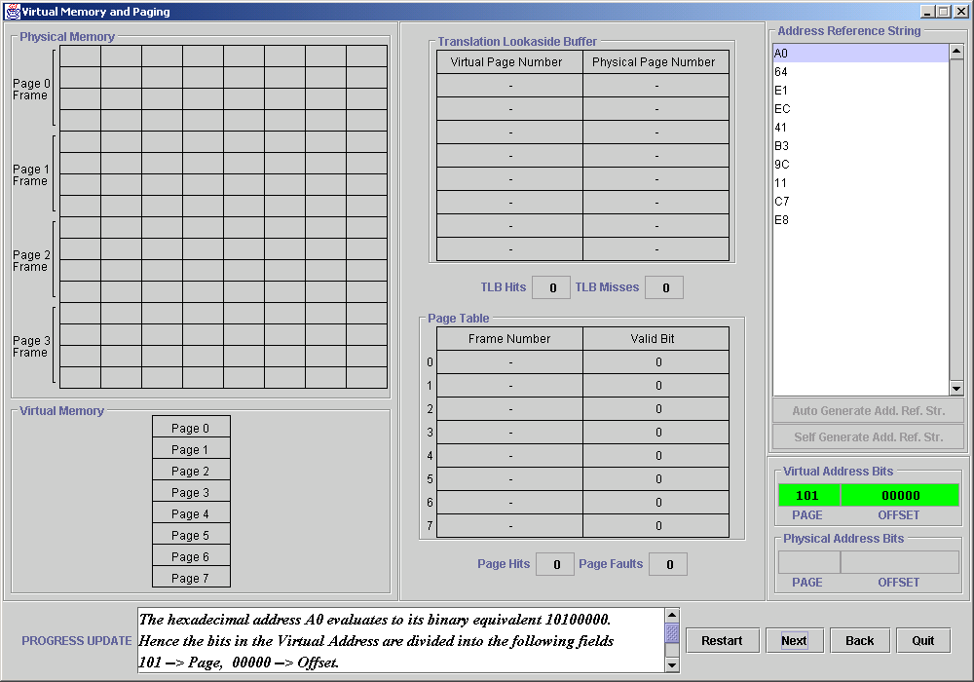
Figure 17: Virtual Memory – Virtual Address Bits

The virtual address bits are highlighted in green. The set of bits below them are the physical address bits, which will be evaluated once the page frame in memory where the virtual page should reside is determined

Now that the virtual page number is determined, the CPU looks in the TLB for a matching entry. Since the TLB contains pairs of virtual page numbers and physical page numbers, a match on the virtual page number can provide the physical page frame where the virtual page resides, if at all.

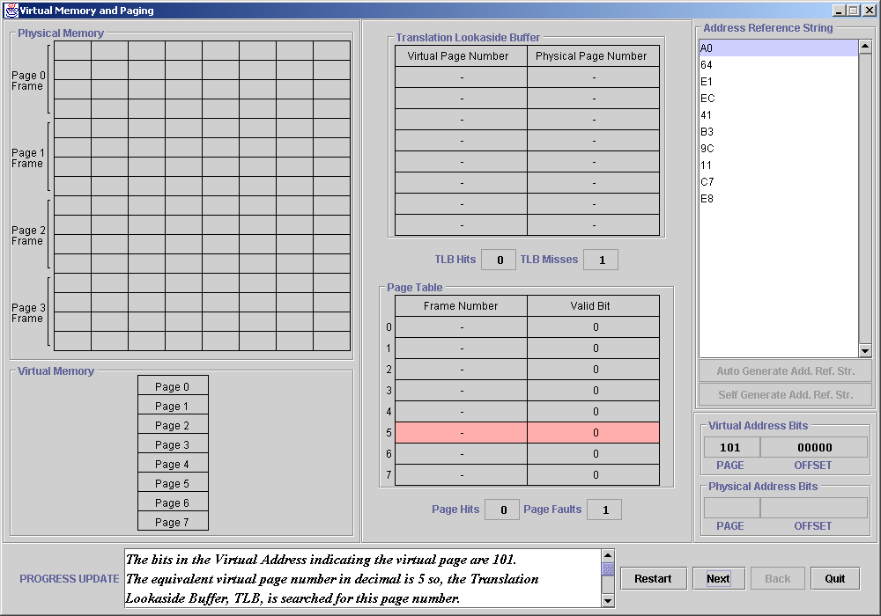
Figure 18: Virtual Memory – TLB and Page Table

In this particular instance, there is a TLB miss since there is no matching entry for the virtual page number. Thus the CPU goes to the page table to try and retrieve the information. The highlighted page table entry shows the entry, which should be looked up. In this example, there is a page fault because the entry for the virtual page has a valid bit of 0, indicating that the page must be brought in from the disk.

But before the page is brought into memory from disk, the simulator highlights, in blue, the memory frame into which the page will be brought. The memory frame is chosen by the following criteria:
- The first available empty memory frame is chosen.
- If memory is full, then a “victim” block is chosen for replacement. As in the earlier cache mapping tutorials, the LRU algorithm was used for the purpose of this workbench.

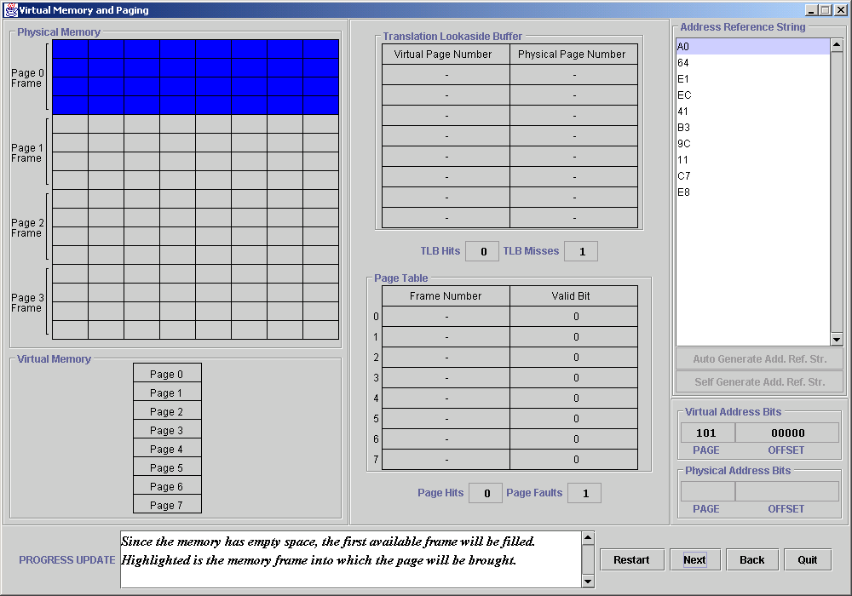
Figure 19: Virtual Memory – Page Frame (empty)

Now the CPU goes to the hard disk to retrieve the page in question. This virtual page is highlighted in yellow.

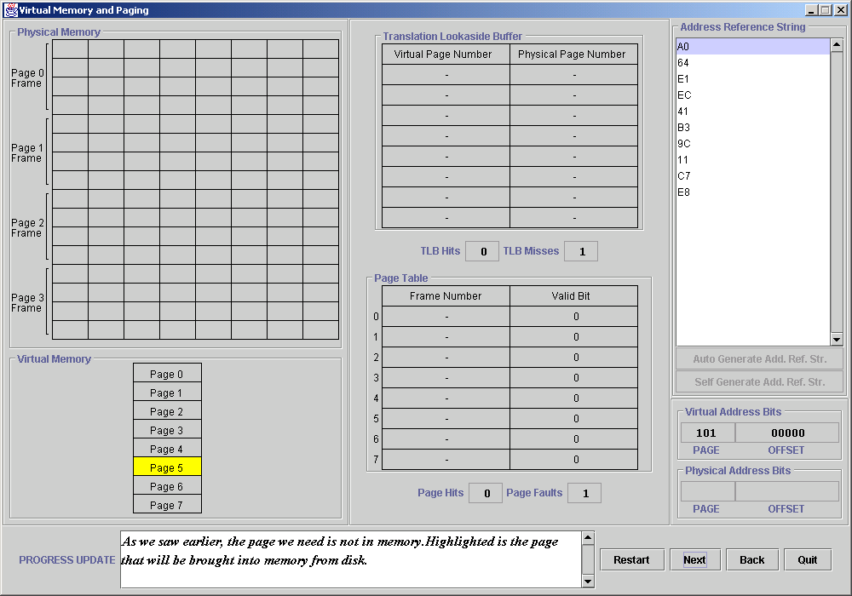
Figure 20: Virtual Memory – Virtual Page

This page is then brought into the memory page frame, and the memory frame is highlighted along with the data it now contains. Additionally, the page table and TLB are updated to reflect this change, and the physical address bits are highlighted to illustrate the translation of the virtual address into the physical address.

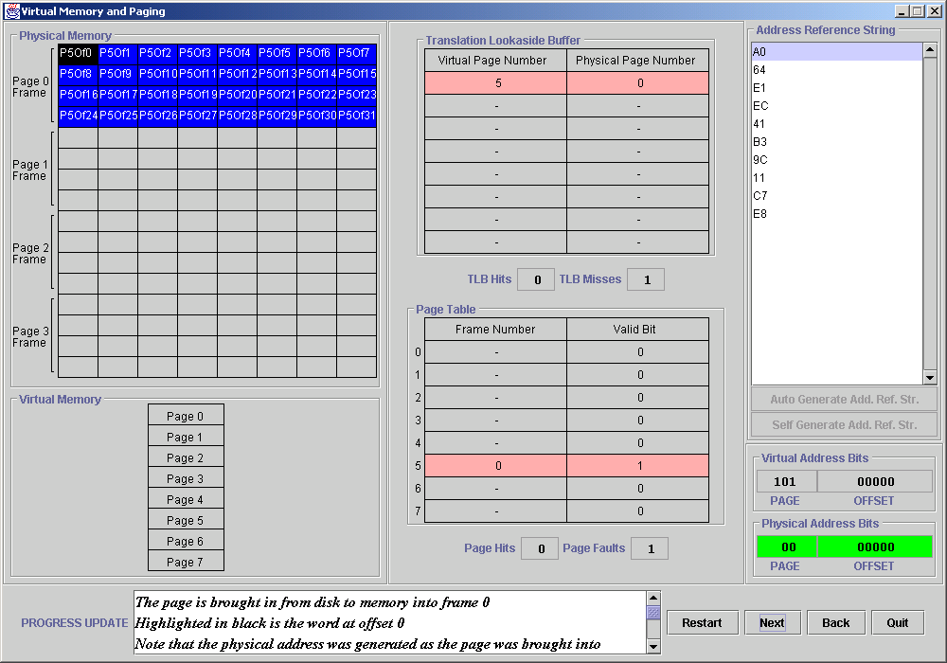
Figure 21: Virtual Memory – Page Frame (full)

